Lab 9: SQL injection - SQL injection UNION attacks
Objective:
- This lab focuses on exploring and understanding Union-Based SQL Injection attacks. Participants will engage with a simulated web application that is vulnerable to SQL injection, specifically through the misuse of the UNION SQL operator. The objective is to learn how to identify, exploit, and subsequently defend against Union-Based SQL Injection vulnerabilities.
In this lab, students need to:
- Answer the following questions:
  - What is a Union-Based SQL Injection attack, and how does it differ from other types of SQL injection attacks?
  - Explain the role of the UNION SQL operator in this type of attack and how it can be used to extract data from a database that is not typically accessible through the intended use of a web application.
- Perform challenge:
  - SQL injection UNION attack, determining the number of columns returned by the query
- Explain and capture all steps (full windows screen capture).

Submit a report addressing all the questions mentioned above in either PDF or Markdown format. Additionally, include a video demonstrating the detailed process of your work to ensure the authenticity of your lab exercise.
The report file name must be Class_YourStudentID _YourName_Lab9

SQL injection UNION attack
This screenshot shows Burp Suite intercepting a vulnerable GET request in the PortSwigger SQL injection UNION lab.
The request contains a parameter that can be modified to test UNION SELECT payloads.
By sending UNION queries with different numbers of NULL values, we observe whether the page loads normally or returns an error.
When the correct number of columns is used, the application responds with HTTP 200 and displays the shop page correctly.
This confirms the number of columns returned by the original SQL query.
Identifying the column count is a required step before extracting sensitive data using a UNION-based SQL injection.
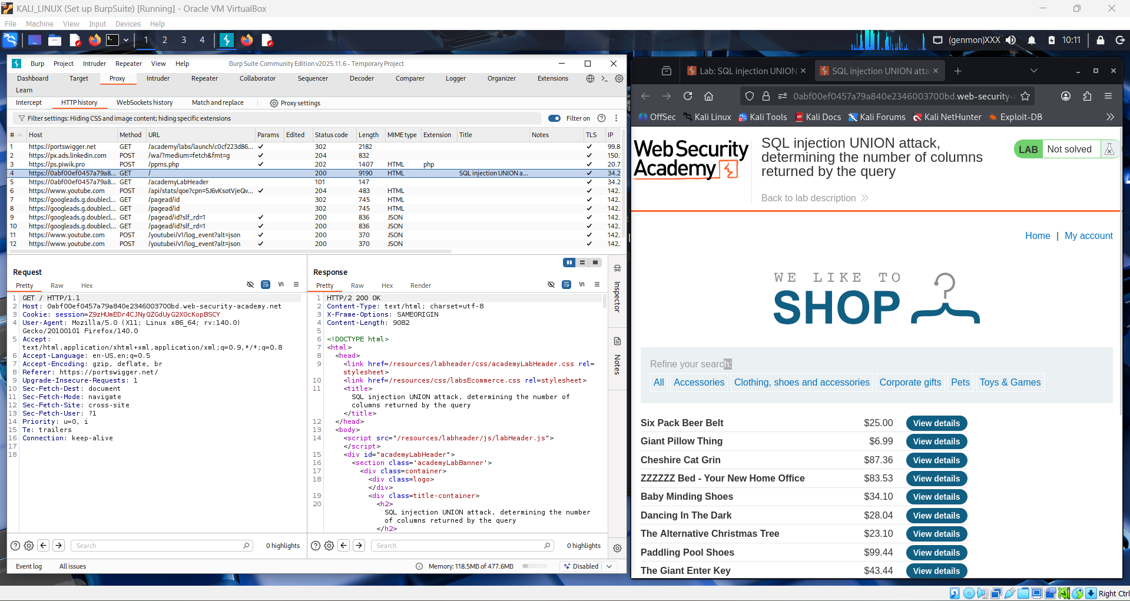

This screenshot shows notes explaining how a UNION-based SQL injection works in the product category filter.
The goal of the lab is to determine the number of columns returned by the original SQL query.
The example demonstrates that both SELECT statements in a UNION must return the same number of columns.
By testing UNION SELECT statements with different column counts, we can identify the correct structure.
When the column count matches, the query executes successfully and the page loads normally.
This step is essential before using UNION to extract hidden data from the database.
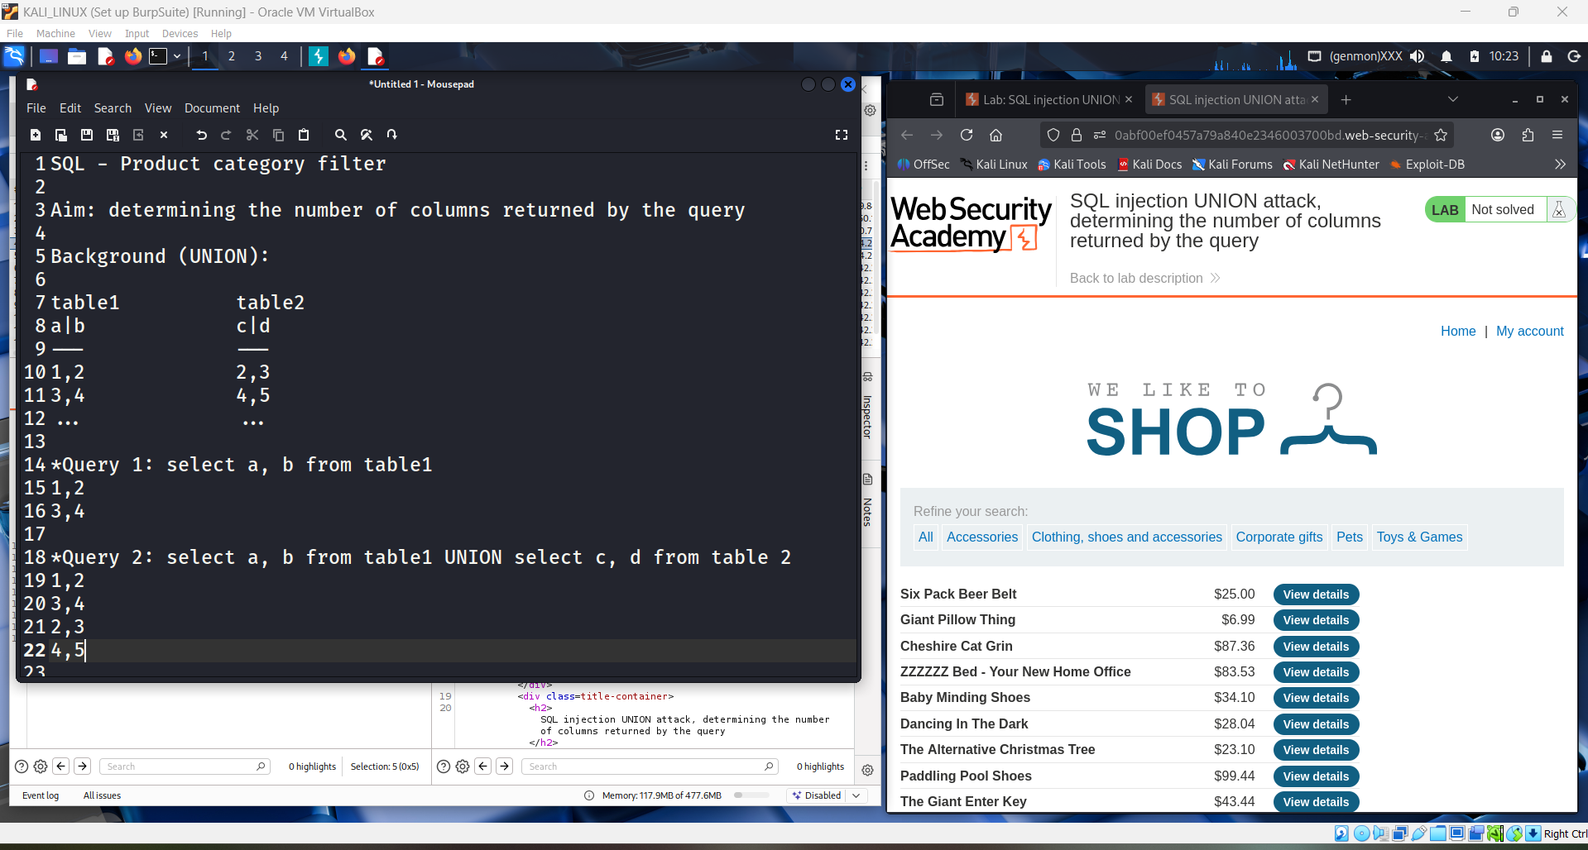

This screenshot shows a conceptual explanation of how the UNION operator works in SQL injection attacks.
It illustrates that both SELECT queries in a UNION must return the same number of columns.
The notes explain how data from two different tables can be combined into a single result set.
Once the correct column count is identified, UNION can be used to select sensitive data such as usernames and passwords.
This demonstrates why determining the number of columns is a critical step in a UNION-based SQL injection.
After this step, attackers can extract data that is not intended to be visible in the application.
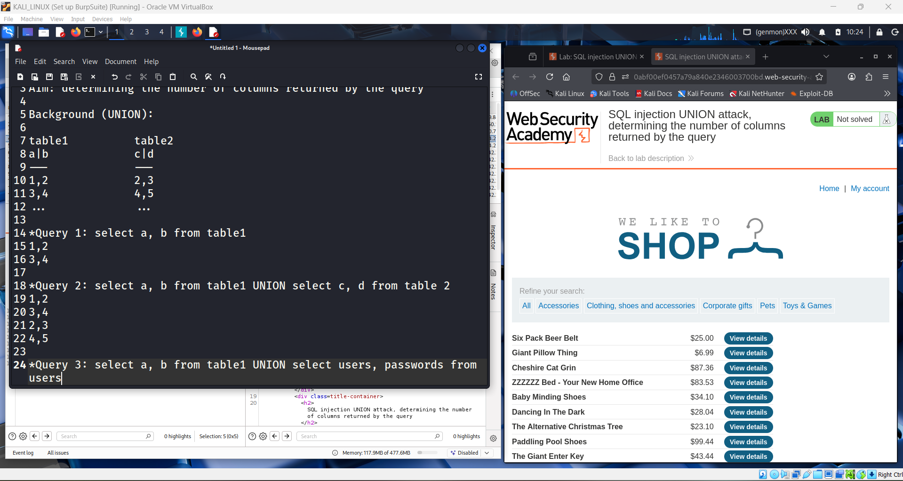

This screenshot explains the rules of the SQL UNION operator used in UNION-based SQL injection attacks.
It shows example queries where data from multiple tables is combined using UNION SELECT.
The notes highlight that all SELECT statements must return the same number and order of columns.
It also emphasizes that the data types of each column must be compatible.
These rules are critical to make the injected UNION query execute successfully.
Understanding this allows attackers to extract sensitive data once the column structure is known.
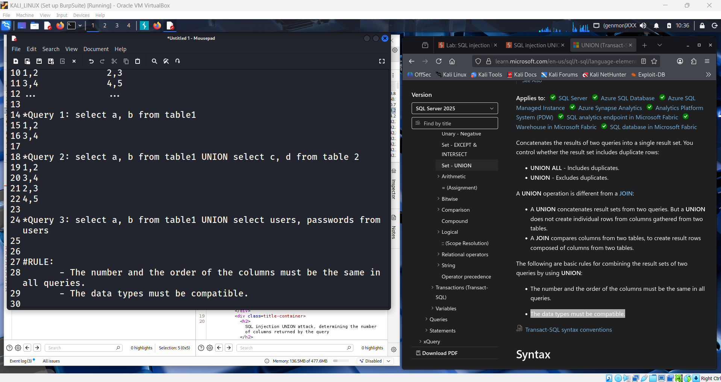

This screenshot demonstrates how to identify the correct number of columns using a UNION-based SQL injection.
The notes show failed UNION SELECT attempts that return errors due to an incorrect column count.
By increasing the number of NULL values, the attacker tests how many columns the original query uses.
When the application returns an HTTP 200 response, it indicates the correct number of columns.
This confirms that the UNION query structure is valid.
Determining the correct column count is a key step before extracting sensitive data from the database.
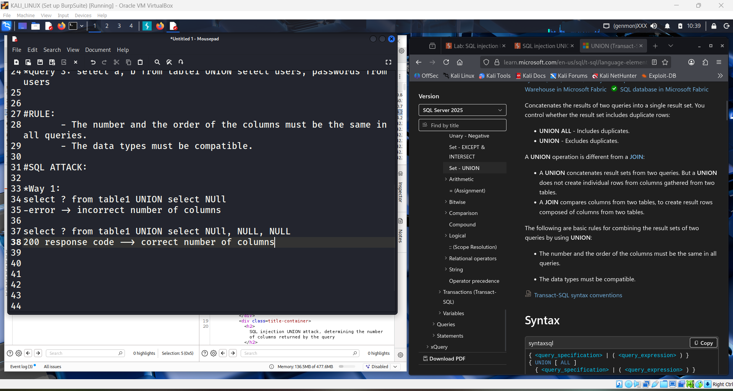

This screenshot shows practical testing of a UNION-based SQL injection on the product category filter.
The notes demonstrate two common methods to determine the number of columns: using UNION SELECT NULL and ORDER BY.
An incorrect column count results in an error message, while a correct count returns a normal page response.
When the page loads successfully with a 200 response, it confirms the correct number of columns.
This step verifies how the backend SQL query is structured.
Identifying the column count is necessary before performing further data extraction using UNION.
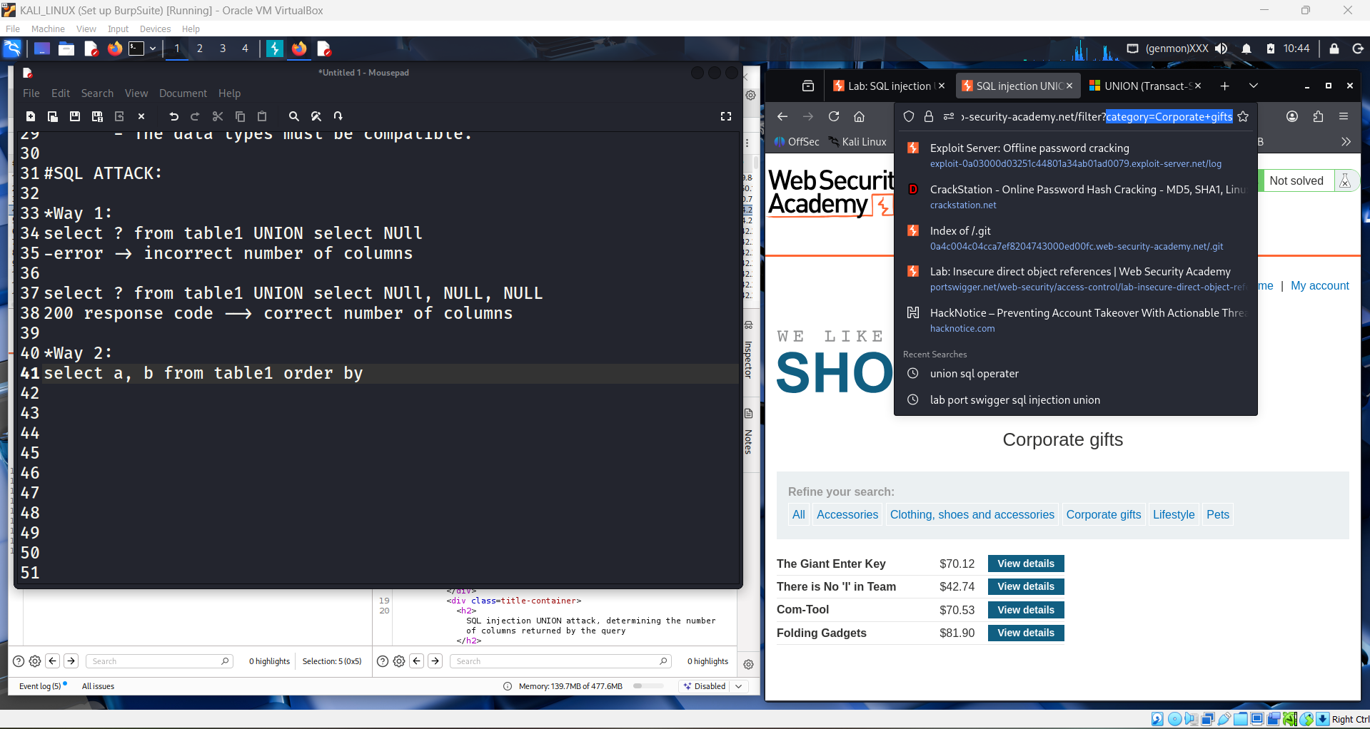

This screenshot shows the result of testing an incorrect SQL injection payload on the category filter.
When the injected UNION SELECT or ORDER BY clause does not match the actual column structure, the server returns an Internal Server Error.
This error indicates that the SQL query syntax or column count is incorrect.
By observing these errors, the attacker can adjust the payload to find the correct number of columns.
Once the error disappears and the page loads normally, the correct query structure is confirmed.
This trial-and-error process is commonly used in UNION-based SQL injection attacks.
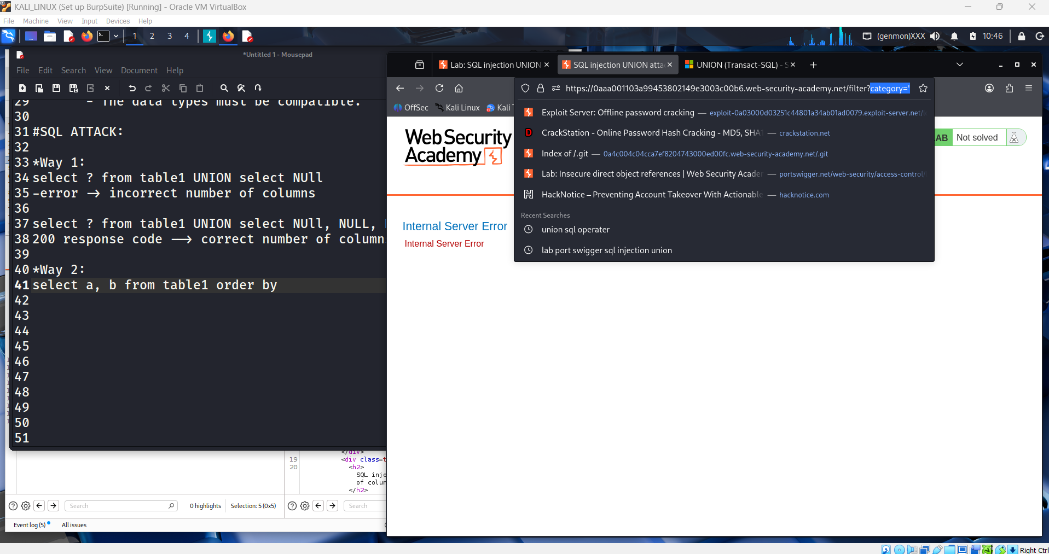

This screenshot shows a UNION-based SQL injection test on the category parameter.
The attacker first tries UNION SELECT NULL to determine the number of columns.
When the number of selected columns is incorrect, the server returns an error.
After matching the correct number of columns, the page loads normally with HTTP 200.
This confirms that the application is vulnerable to UNION-based SQL injection.
The attacker can then use this technique to extract data from the database.
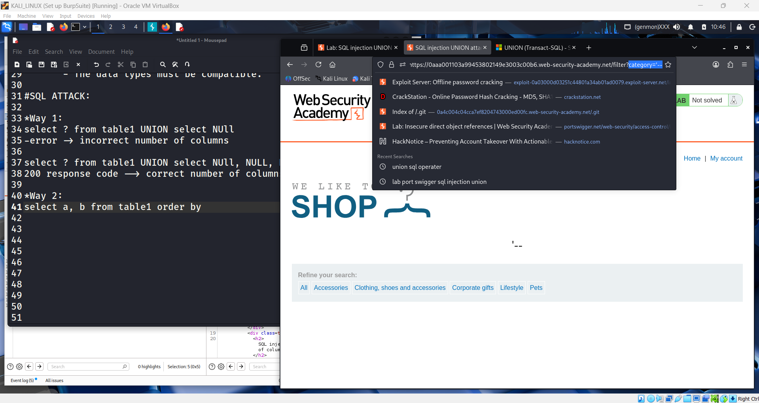

This screenshot shows a failed UNION-based SQL injection attempt.
The attacker injects UNION SELECT NULL into the category parameter.
Because the number of selected columns does not match the original query,
the server returns an Internal Server Error.
This error helps the attacker identify that the column count is incorrect.
It is used as a step to determine the correct UNION query structure.
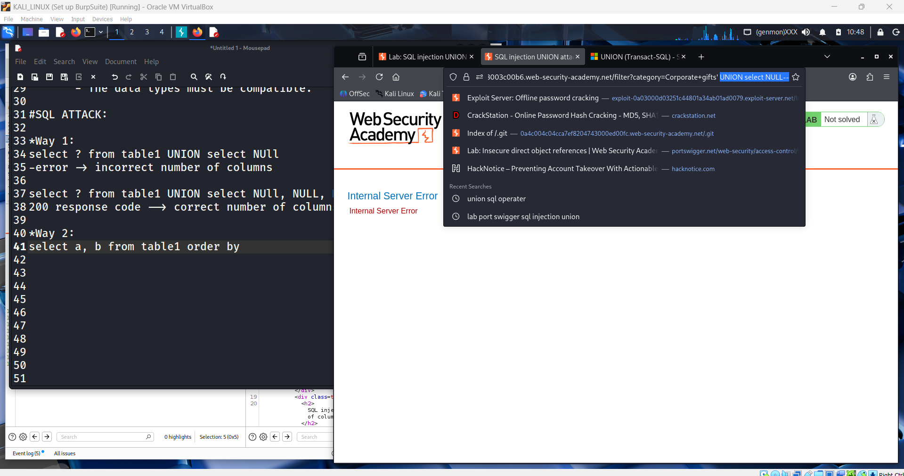

This screenshot shows a UNION-based SQL injection test captured in Burp Suite.
The attacker injects UNION SELECT NULL into the category parameter.
The server responds with an Internal Server Error (500).
This indicates the UNION query structure is invalid.
The error helps identify that the number of columns is incorrect.
It is a step to determine the correct column count for a successful UNION attack.
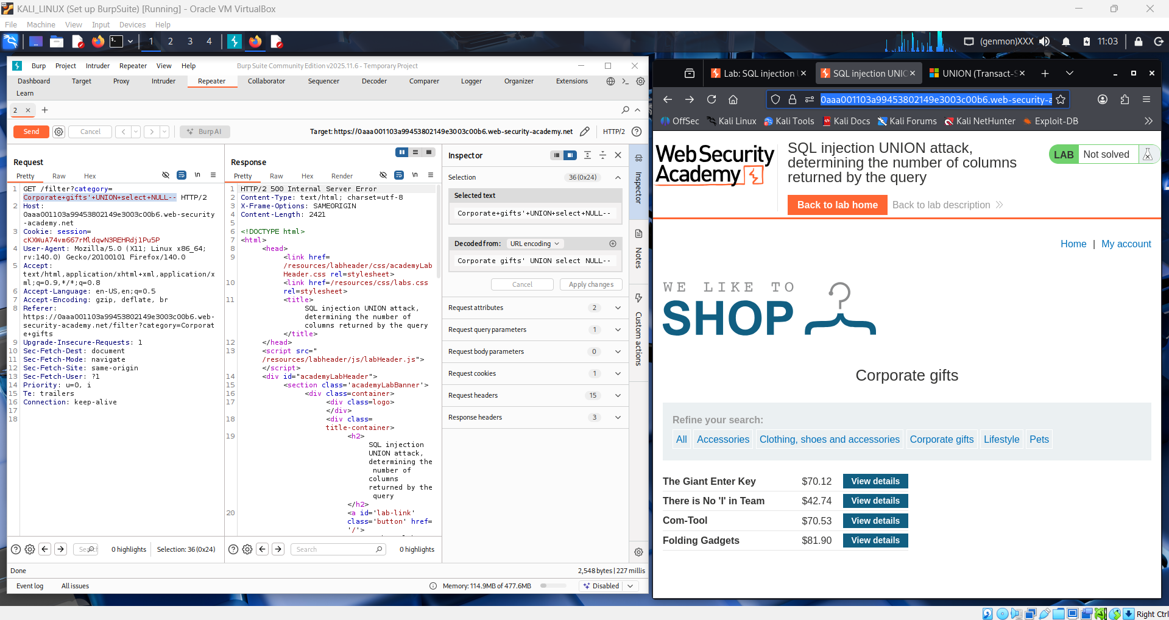

This screenshot shows a UNION-based SQL injection attempt analyzed in Burp Suite.
The payload UNION SELECT NULL is injected into the category parameter.
The server returns an HTTP 500 Internal Server Error.
This indicates the UNION query is syntactically incorrect.
The error suggests a mismatch in the number of columns.
This feedback is used to identify the correct column count for a successful UNION attack.
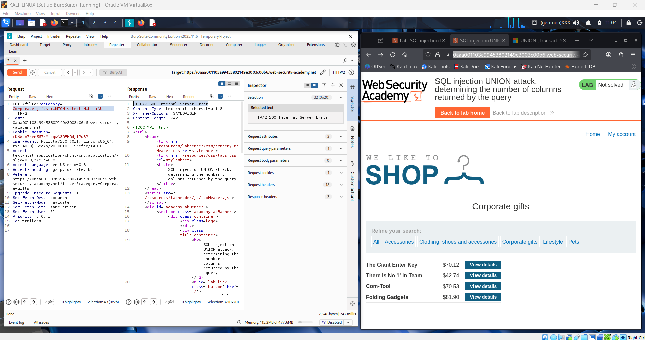

This screenshot shows a successful UNION-based SQL injection identified using Burp Suite.
The payload UNION SELECT NULL, NULL, NULL is injected into the category parameter.
The server returns an HTTP 200 OK response instead of an error.
This confirms the correct number of columns in the original query.
The lab is marked as solved after determining the valid column count.
This step is essential for extracting data using UNION-based SQL injection.
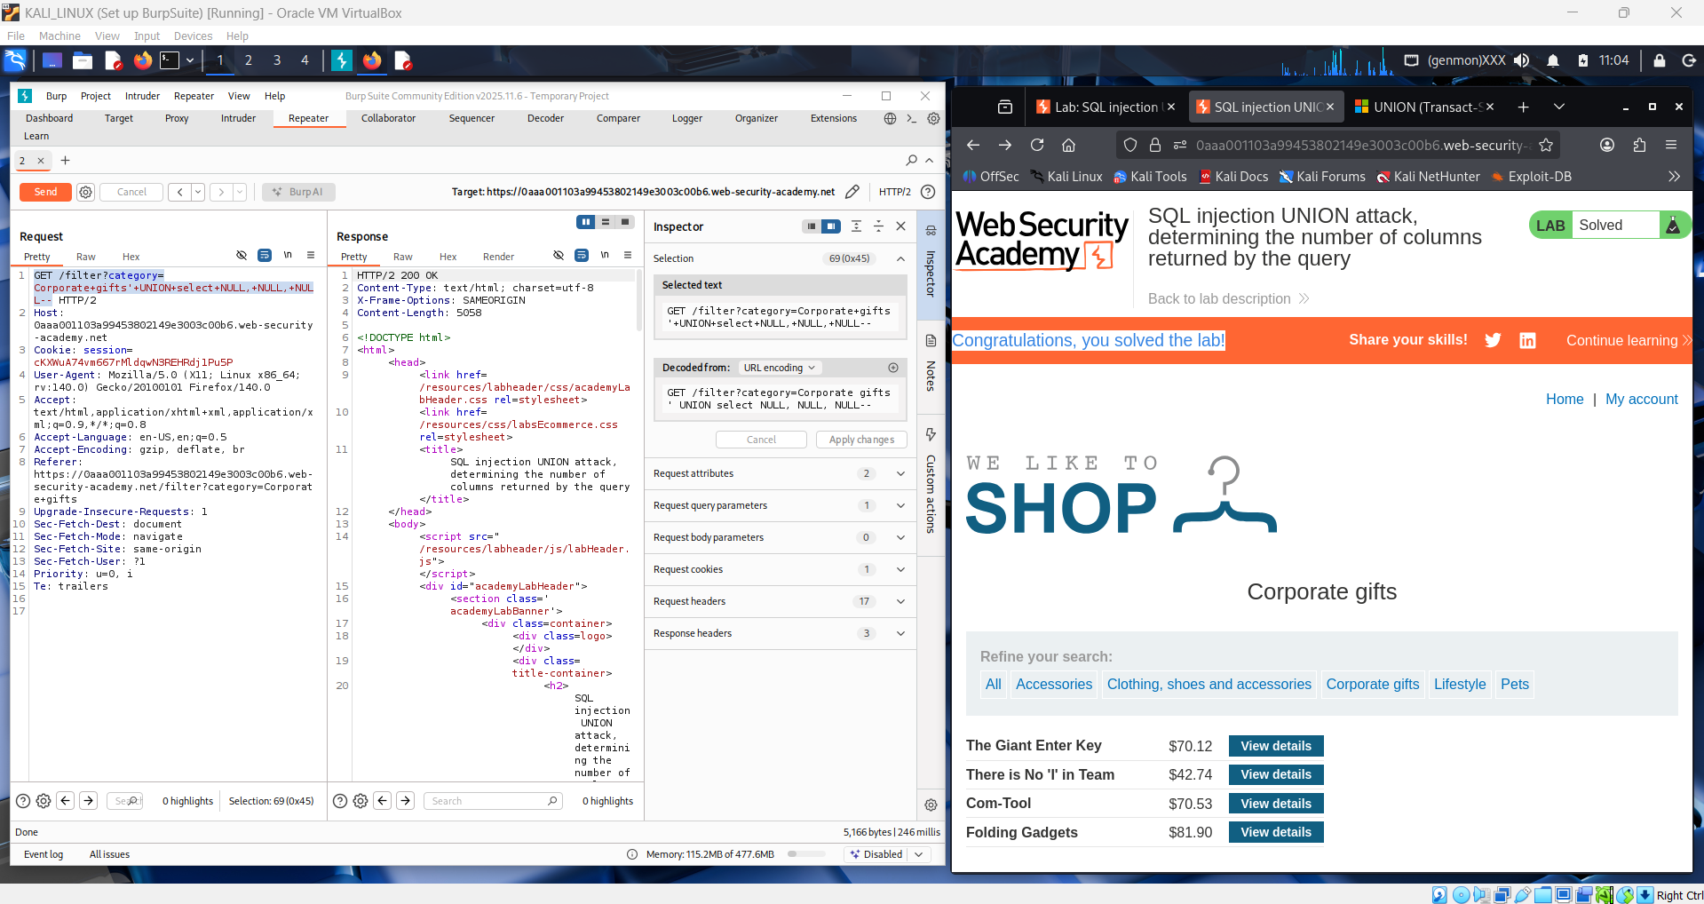
Conclusion:
This lab demonstrates how UNION-based SQL injection can be used to exploit vulnerable input fields to extract hidden database information. By identifying the correct number of columns, attackers can combine malicious queries with legitimate ones to retrieve sensitive data. The lab highlights the importance of proper input validation and secure query handling.
Q1. What is a Union-Based SQL Injection attack, and how is it different?
A UNION-based SQL injection attack exploits the UNION operator to combine the results of a malicious query with a legitimate query. Unlike error-based or blind SQL injection, it directly displays extracted data in the application’s response.
Q2. Role of the UNION operator in this attack:
The UNION operator merges results from two SELECT statements into one output. Attackers use it to fetch data from other tables (e.g., users, passwords) that are not intended to be accessible through the application’s normal functionality.

